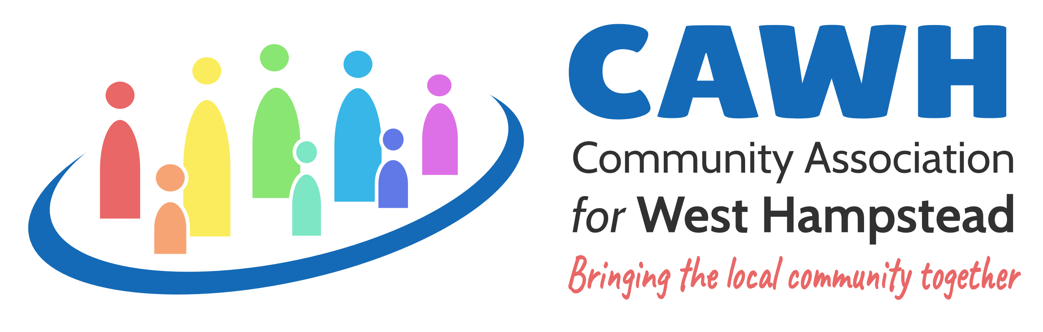

Dear Friend
Thank you for expressing an interest in becoming a CAWH 101 Club member.
Accompanying this letter is an Application Form and a Bank Standing Order form.
The 101Club is set up to raise funds for the Community Association of West Hampstead so that we can continue our programmes of support for children, young people and older members of our community. Your contribution is invaluable!
To become a member please complete the Application Form and return it to me. You can do this by:
- attaching the completed form to an email sent to 101club@cawh.org.uk
- or by post to: Geoff Berridge, 64 Hillfield Road, London, NW6 1QA
I will then send the standing order form to your bank. You can set up the standing order directly yourself if you prefer, please see details on the Application Form. For further information please contact me at 101club@cawh.org.uk or 020 7794 9723.
We will draw a winner from the Club membership each month. The winner will receive £60. They will be notified and the money transferred to their bank account. The CAWH Newsletter will announce the name of the monthly winners.
You can leave the Club at any time by letting me know and cancelling your standing order.
We look forward to you becoming a member of CAWH’s 101 Club and wish you every success. Thank you for your support!
Best wishes,

Geoff Berridge
(CAWH 101Club Organiser, Community Association for West Hampstead)

Community Association for West Hampstead, 17 Dornfell St, London NW6 1QN, www.cawh.org.uk. Charity No 1135778: Company Ltd by Guarantee No 06956009

